

**Topic : Stamp Collecting world**

**End Term Report**

**SUBMITTED BY**

**Roll no NAME** **REGISTRATIONNUMBER**

34 Aman Upadhaya 11909734

35 P. Udith Narayana 11906447

36 Mohd Areeb 11909893

**Department of Intelligent systems,**

**School of Computer Science and Engineering,**

**Lovely professional University, Jalandhar,**

**April-2020.**

**Student declaration**

This is to declare that this report has been written by me/us. No part of the report is copied from other sources. All information included from other sources have been duly acknowledged. I/We aver that in any part of the report is found to be copied, I/we are shall take full responsibility for it.

**TABLE OF CONTENTS**

* Abstract
* Introduction
* Literature Review
* Proposed Methodology
* Result and Discussion
* Analysis
* Work division among students
* Conclusion
* References

BONAFIDE CERTIFICATE

Certified that this project report “Stamp Collecting world” is the bonafide work of “Aman Upadhaya , P .Udith Narayana ,Mohd Areeb” who carried out the project work under my supervision.

Abstract

Stamp collecting began almost immediately after the issue of the first adhesive postage stamp. Great Britain issued the first postage stamp on May 6, 1840. It is referred to by philatelists as the Penny Black (see scan below). Many people purchased the 1 Penny stamp on the first day of issue, not for the purpose of using it on letters, but for the purpose of saving them as historical mementos.

**Advantages**:

All stamp collectors agree (even if not everyone admits it) that what motivates them to collect stamps is the pure simple joy they feel when collecting. The process of searching, locating and buying common stamps, new stamps, old stamps, rare stamps, or any other types of stamps which are needed in order to complete a specific type of stamp collection gives the stamp collector a sense of pride, success and accomplishment. For some people, just the simple and pure fun of the hunt (similar to treasure hunting), and the moment of actually finding and successfully acquiring a particular stamp is a good enough reason to collect stamps. Stamp collectors enjoy the moment when they get praised by family, friends, and other collectors regarding their stamp collections at stamp exhibits. Similarly, stamp collectors who put up personal websites showing their collection love the feeling of joy every time someone makes a positive feedback about their stamps.

Introduction :

In this project , we have made the demo model of a webpage which can withstand with the present day working websites . The idea of this model is to make an easy user interface which can be accessed by everyone easily.

In brief, the page we have designed can be used for further linking with the database and can be used as an official website . we can search the wanted stamps, because of these online stamps people cannot waste their time in searching the stamps as there is a lot of usage of those sites in everyday life.

So, this module gives us the information about how we can create a simple webpage with all the required components needed.

Our page works in a simple way , where the user gets logs into his account and then look for their stamps where they need the stamps they can use and they can share with their friends also and successfully and the site returns to the homepage after the completion of this whole process.

The objective of the project assigned is to make a simple user interface for stamp collecting world . In order to that, we have made an interface where the users can easily understand the modules in the site and country stamps and post stamps easily .

The interface we have designed will be official enough with all the basic required modules in that like home module and many paths like search, etc where the process is not so complex in developing the interface but also for the user

**DESCRIPTION OF THE PROJECT**

Our project consists of the following modules :

* Home module
* Search module
* Stamps collecting module
* Stamps Albums module
* Stamps Catalogs module
* FAQ’s module

**Home module :**

In the home page, all the modules are displayed and the page also shows the information and news about the Stamps ,there will be a portal displayed in the home page so that ,one can check the Stamps .The other modules that are displayed on the home page will direct us into the required page.

**Search module :**

In this module , their will be a box in top of the web page and if we want to find any stamp or matter if we write the discrepancy it will takes us to the respective page and we can see which matter we want we can write and also we can share

**Description of work division in terms of roles** :

The project has been designed by three members ,in which the project synopsis has been made by the three of us ,where the work has been equally divided among us and in the website interface creation, the login module has been designed by Aman Upadhaya K19HKA34, Mohd Areeb K19HKB36 and the homepage has been done by P. Udith Narayana K19HKA35.

The work has been divided into three categories and have been performed by all the three members of our group .

**Literature Review :**

Technologies and framework used.

The framework and technology used in this project is html , css , javascript.

**Implementation of work project**

HOME PAGE:

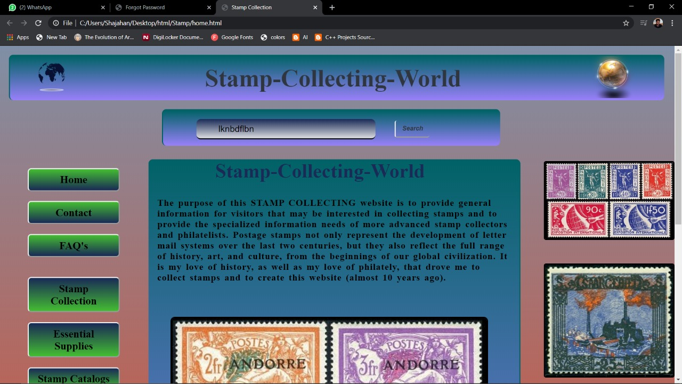

COLLECTION WORLD PAGE:

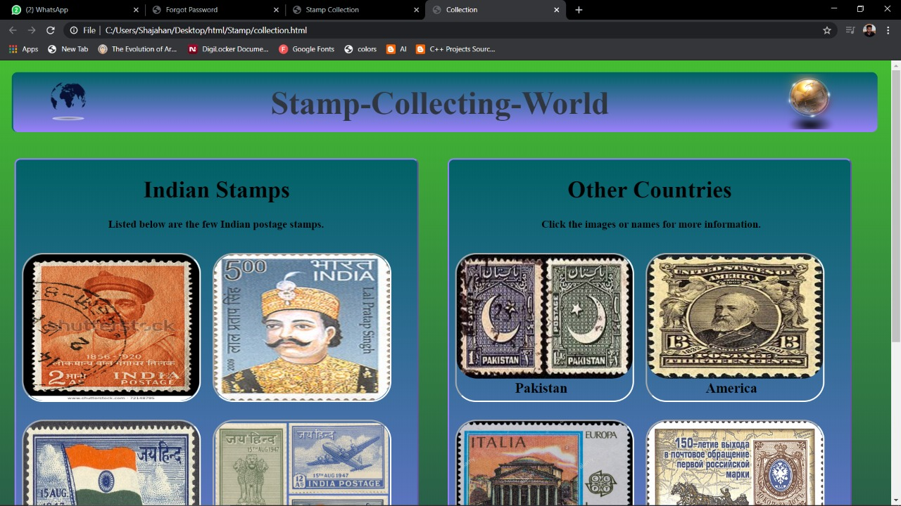

FAQ’s:

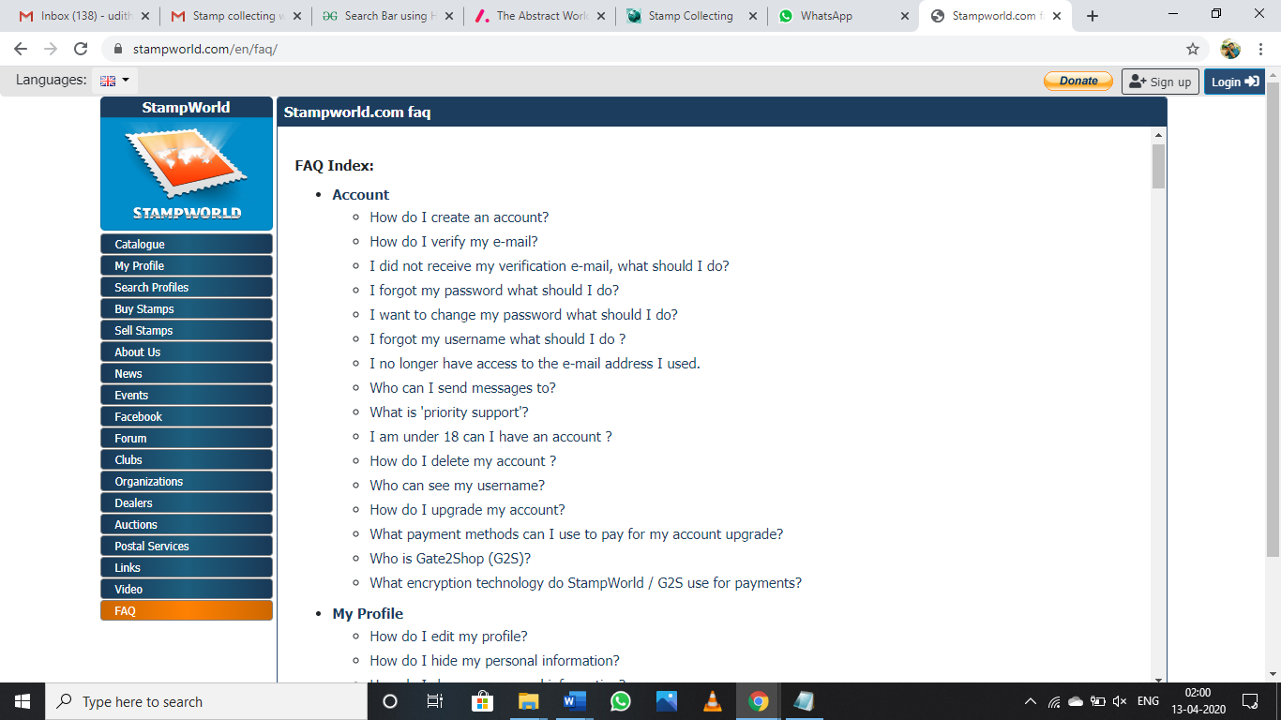

Information:

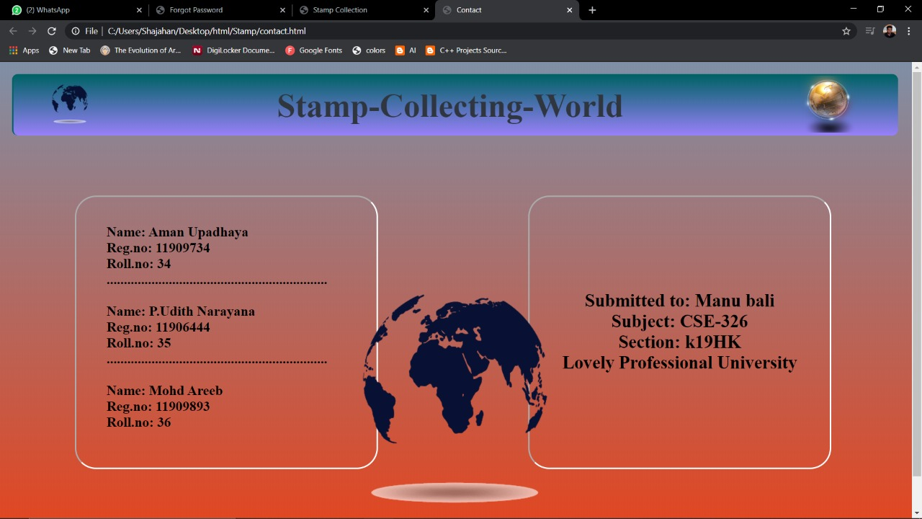

**Proposed methodology :**

In making this project, we have used the components of html, css and java and the process of working of the website goes on in the following way . First of all ,the homepage is displayed where one can find the Stamps we required. After that Stamps can be visible ,if he already has an account in that website by providing the required details ,else he can create his own account in that website by signing in ,after the sign up the user will be taken into the page where one can find about the Stamp details, thus leading transparency in everyway.

**Analysis of the project**

This simple webpage interface is easily accessible and understandable. If this is implemented completely with the connection of a database, this can compete with the webpages in the present world and can be useful to the people ,since there is lot of need of such websites for the people for simplification of their life.

**Conclusion :**

This kind of webpages helps everyone in making their tasks easy and convenient , thus we can say that this can also help in decreasing the inconvenience caused by having very few number of online portals ,since these can help in increasing the online stamps collecting sites.

**References:**

We have used the online platforms like w3 schools to present in a special way and also used the notes given to us, in making the kind of website model we have done here.

Thank you.